Global Inflation Analysis & Predictive Insights Report
Prepared Using Python, SQL, and Machine Learning

Introduction
This report analyzes global inflation trends across countries using historical data. The objective is to identify patterns in inflation, deflation, and economic stability to support decision-making for policymakers, investors, and businesses.
Tools Used:
- Python for data cleaning, preprocessing, and machine learning
- SQL for data analysis and aggregations

Step 1: Data Cleaning & Preprocessing (Python)
The World Bank inflation dataset was loaded and examined. Missing values in the Inflation column were identified and removed to ensure accuracy. The dataset was reshaped into a long format to facilitate analysis. Extreme outliers were filtered using the Interquartile Range (IQR) method. The Year column was converted to numeric type for modeling purposes.
Purpose:
Cleaning ensures that analyses are not skewed by missing or extreme values and that the data is structured for reliable statistical and machine learning modeling.
Step 2: Exploratory Data Analysis (EDA)
To understand global inflation trends and patterns, we performed exploratory data analysis:
- Top 10 Countries by Average Inflation:
A bar chart was created to identify countries with the highest average inflation. This highlighted countries such as Congo, Angola, and Brazil, which experienced extremely high inflation, indicating economic instability.
- Global Average Inflation Over Time:
A line chart showed how average inflation evolved globally from 1960 to 2024. Some years, like 1985 and 1994, experienced significant spikes, revealing periods of high global inflation.
- Country-specific Trends:
Plots for individual countries (e.g., Australia) were analyzed to observe unique inflation patterns over time, helping to understand country-level variations.
- Distribution of Inflation Values:
A histogram revealed that most inflation values were moderate, while a few extreme values created a long tail, demonstrating the skewed nature of the dataset.
- Inflation Variability and Outliers:
Boxplots for selected countries (Australia, United States, India, Brazil, Germany) illustrated variability and the presence of outliers, confirming the need to filter extreme values for modeling.
Purpose:
These visualizations helped identify patterns, anomalies, and the impact of outliers. They informed decisions on feature selection, outlier handling, and the modeling approach in subsequent steps.
STEP3- Business Analysis Using SQL
After exploring the data in Python, the dataset was connected to a PostgreSQL database to answer specific business questions
Purpose:
Using SQL allowed efficient aggregation, ranking, and filtering of large datasets. This step provided actionable insights and confirmed patterns observed during EDA, bridging data analysis with business decision-making.
Outcome:
The SQL queries verified our observations from Python visualizations, providing a stronger foundation for predictive modeling. Insights such as the countries with extreme inflation spikes and years with unusual trends were clearly identified and documented.

SQL Output – Data Overview:
1. High-Risk Countries:
Which countries experienced consistently high inflation over the last 60+ years, indicating potential economic instability for investors or policymakers?

OUTPUT:
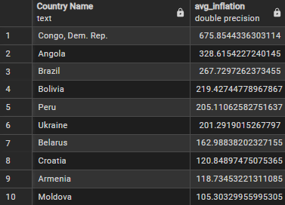
Congo, Dem. Rep., Angola, and Brazil show the most extreme average inflation, reflecting severe macroeconomic instability and high currency volatility over decades.
Countries like Ukraine, Belarus, and Moldova also show significant average inflation, suggesting persistent economic and political risks affecting pricing, investment, and policy planning.
For investors and policymakers, these countries represent high-risk environments requiring inflation hedges, careful currency management, and risk-adjusted investment strategies.
2-Deflation Concerns:
Which countries experienced periods of negative inflation, signaling possible economic slowdown or risk for businesses operating there?
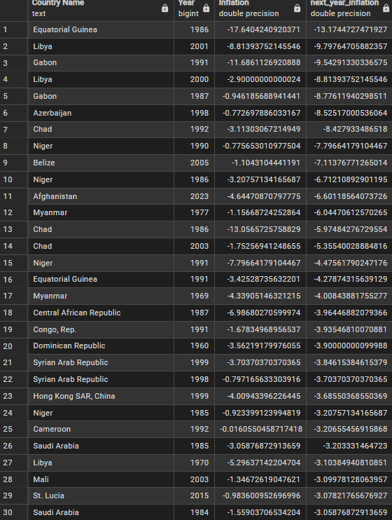
Countries that experienced periods of negative inflation, indicating potential economic slowdown or risk for businesses, include Equatorial Guinea, Lesotho, Chad, Libya, Ethiopia, Central African Republic, and Niger. These deflationary episodes suggest reduced consumer demand and economic instability in these regions.

3 Volatility Leaders:
Which countries have the most volatile inflation rates, and how might this affect pricing strategies, investment, or import/export decisions?
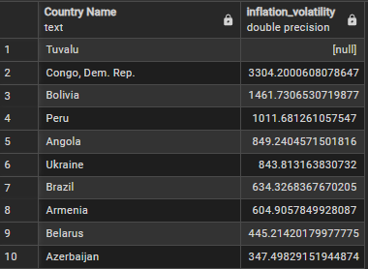
Countries with the most volatile inflation rates include Congo (Dem. Rep.), Bolivia, Peru, Angola, Ukraine, Brazil, Armenia, Belarus, and Azerbaijan.
High volatility in inflation makes pricing strategies, investment planning, and import/export decisions more challenging, as businesses face unpredictable costs, fluctuating consumer demand, and currency risks. This environment often requires flexible pricing, hedging strategies, and careful risk management.

4 Global Inflation Trends:
How has average global inflation changed over time, and what macro trends can businesses anticipate?
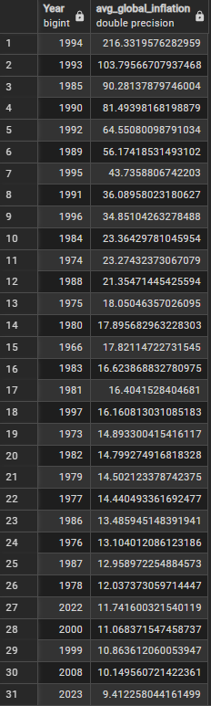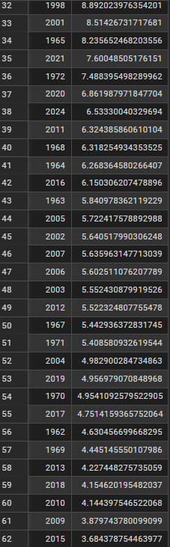
Average global inflation has fluctuated over the last six decades, with extreme spikes in the 1990s and renewed increases in 2022–2023, reflecting global shocks and emerging market pressures. Businesses should anticipate periodic inflationary volatility when planning pricing, investment, and supply chain strategies.

5 Regional Stability:
Which regions (e.g., Africa, Europe, Asia) have the most stable vs. unstable inflation patterns, and how should companies adjust regional operations?
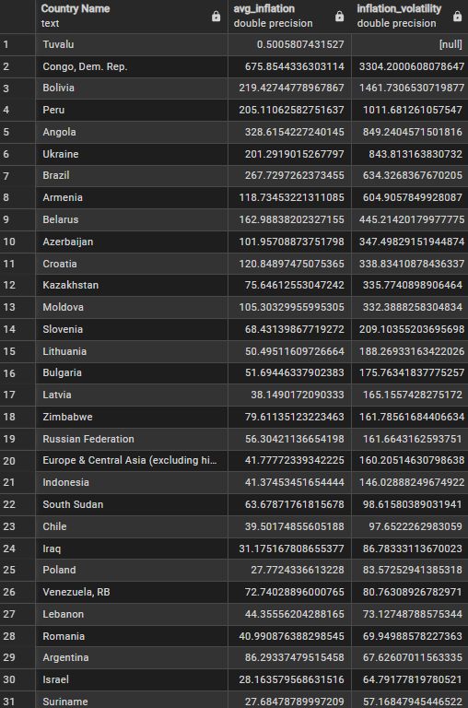
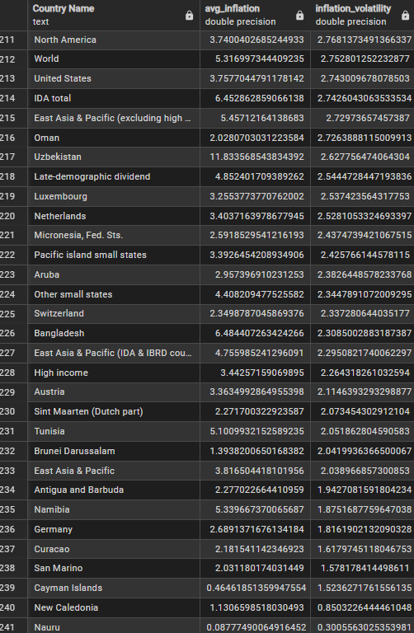
The analysis of average inflation and inflation volatility shows that countries like Congo, Dem. Rep., Bolivia, Peru, and Angola exhibit the highest inflation volatility, while countries such as Tuvalu, Nauru, and New Caledonia have the lowes
6 Yearly Inflation Spikes:
Which years had unusually high inflation spikes, and what events or crises might explain these peaks?
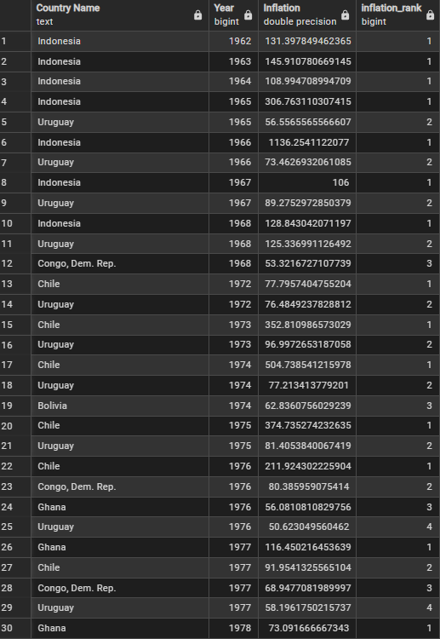
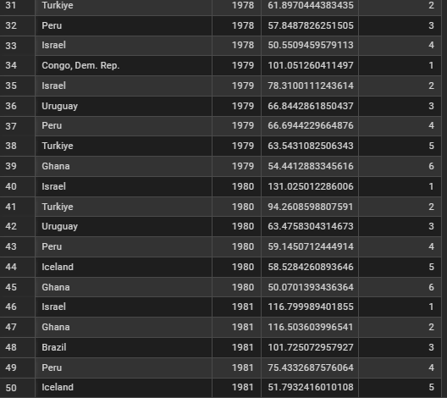
Between the 1960s and 1980s, Indonesia, Chile, Ghana, and Israel experienced dramatic inflation spikes. Indonesia’s inflation peaked over 1,100% in 1966 due to political turmoil, while Chile saw massive inflation during the early 1970s following economic instability and the 1973 coup. Ghana and Israel faced double-digit surges in the late 1970s and early 1980s due to economic mismanagement and global crises.
7- Impact on Emerging Economies:
Which emerging economies faced rapid inflation growth, potentially affecting foreign investment and local purchasing power?
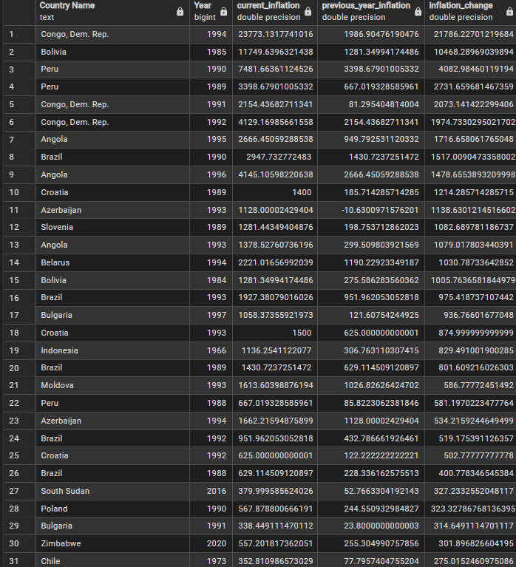
Countries like Congo, Dem. Rep., Bolivia, Peru, Angola, and Brazil experienced extreme inflation surges during the 1980s and 1990s, with Congo reaching over 23,000% in 1994, Bolivia over 11,000% in 1985, and Peru surpassing 7,400% in 1990, reflecting political instability, economic mismanagement, and hyperinflation crises that likely strained foreign investment and eroded local purchasing power.

8 -Long-Term Deflation Patterns:
Are there countries with long periods of deflation or very low inflation, and how might this influence monetary policy or business pricing?
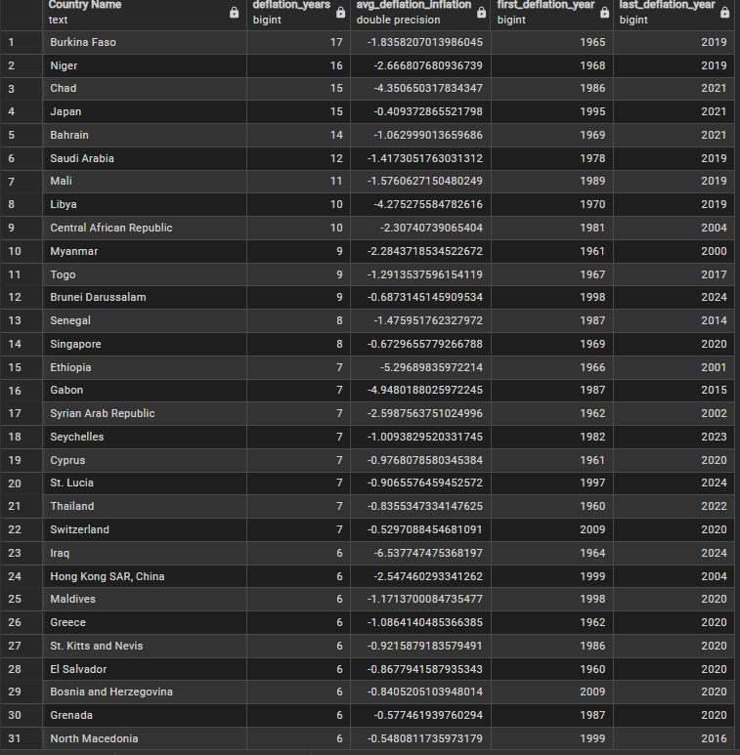
Several countries, including Burkina Faso, Niger, Chad, and Japan, have faced prolonged periods of deflation or very low inflation, with some spanning over 15 years. Such sustained low or negative inflation can pressure central banks to adopt expansionary monetary policies, including lower interest rates or quantitative easing, while businesses may struggle to raise prices, potentially compressing profit margins and discouraging investment.
9-Inflation Comparisons Across Similar Economies:
Among countries with similar GDP levels, which ones had higher or lower inflation, and what lessons can policymakers or businesses learn?

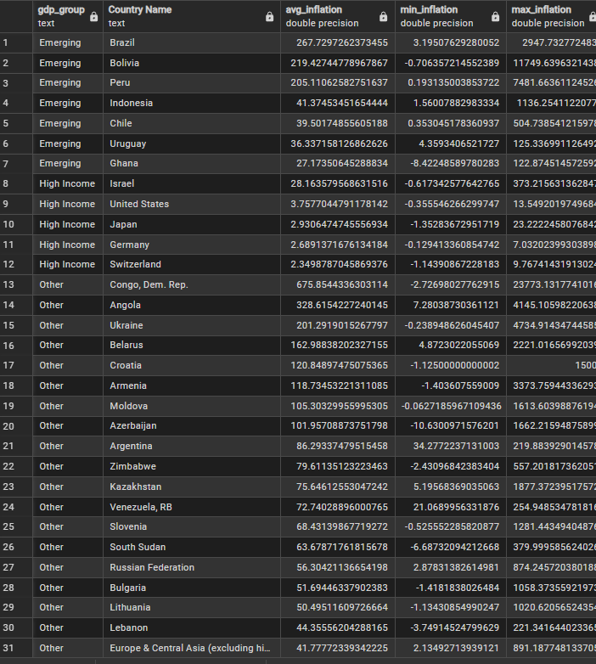

Among countries with similar GDP levels, inflation varies widely: emerging economies like Brazil, Bolivia, and Peru experienced extreme volatility, while peers such as Chile and Indonesia maintained moderate inflation, and high-income countries generally exhibited low and stable inflation, highlighting the critical role of credible monetary policy, fiscal discipline, and institutional stability for both policymakers and businesses operating in these markets.”

10-Predictive Insights:
Based on historical trends, which countries are likely to experience higher inflation in the next decade, informing investment, pricing, or supply chain decisions?

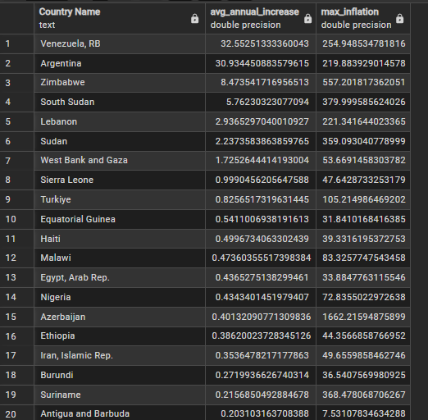
Based on historical inflation growth rates and recent IMF/forecast data, countries such as Venezuela, Argentina, Zimbabwe, South Sudan, and Sudan are most likely to continue experiencing higher inflation over the next decade, which could erode local purchasing power and require cautious investment, pricing, and supply chain strategies in these markets.”

Step 5: Modeling
5.1 Linear Regression (Baseline)
We first used a simple linear regression model using only the Year feature. This served as a baseline to assess whether time alone could explain inflation trends.
Results:
The model performed poorly, with an R² value of approximately 0.04. This indicated that the year alone could explain only a small fraction of the variation in inflation, highlighting the need for more complex modeling.

5.2 Random Forest Regression
Next, we used a Random Forest model with both Year and Country as features, along with the log-transformed inflation values as the target. This model is capable of capturing non-linear relationships and handling variability across countries.
Results:
- R² Score: ~0.63 (log scale), showing that the model explains about 63% of the variance in inflation.
- Mean Squared Error: 0.335 (log scale).
The scatter plots of predicted versus actual inflation values confirmed that the model performed well for the majority of countries and years. Feature importance analysis showed that country-level differences were the strongest contributors, while year trends also had a significant effect.
Random Forests are suitable for complex, non-linear patterns and help capture both temporal and country-specific variations, improving prediction accuracy compared to simple linear regression.

Step 6: Interpretation & Insights
- Some countries experienced extreme inflation spikes, indicating periods of economic instability.
- Emerging economies showed rapid inflation growth, affecting purchasing power and economic planning.
- Long-term deflation was observed in some countries, potentially limiting economic expansion.
- Historical trends indicate that future inflation risks vary significantly across regions.
- The modeling confirmed that both time and country-level factors strongly influence inflation trends.

Conclusion
The project highlights the importance of understanding inflation patterns globally. Simple linear models are insufficient, while Random Forest models provide a more reliable approach to predicting inflation. Using both historical data and country-specific features, we achieved a moderately strong predictive model that can guide business and policy decisions.

Future Work
- Include additional macroeconomic indicators (GDP, CPI, unemployment) to improve predictions.
- Explore more advanced models such as Gradient Boosting or XGBoost.
- Focus on improving predictions for extreme inflation values.
- Develop interactive dashboards for real-time monitoring and visualization of trends.

Project Summary
In this Global Inflation Analysis project:
- Data Source: World Bank inflation and consumer price data
- Python: Data cleaning, preprocessing, reshaping, and modeling
- SQL (PostgreSQL): Data aggregation, ranking, and insights
- Machine Learning: Random Forest model for inflation prediction
- Visualization: Matplotlib and Seaborn.

